Two-Way ANOVA (2B)
Amyah Espanol - APM1111 Statistical Theory
Colab Python Code & Files
https://colab.research.google.com/drive/1cCnflJr-WPJiX-wxV6SxM2n8lm5IGHR0?usp=sharing
https://github.com/amyahespanol/Amyah-Espanol-Statistical-Theory-APM1111
Introduction
If you want to determine if there are any statistically significant differences between the means of independent groups that have been split on two factors, use a two-way analysis of variance (ANOVA) . The researcher can see if the effect of one factor depends on the level of the other.
Assumptions
- Assumption #1: Your dependent variable should be measured at the continuous level (i.e., they are interval or ratio variables).
- Assumption #2: Your two independent variables should each consist of two or more categorical, independent groups.
- Assumption #3: You should have independence of observations, which means that there is no relationship between the observations in each group or between the groups themselves.
- Assumption #4: There should be no significant outliers.
- Assumption #5: Your dependent variable should be approximately normally distributed for each combination of the groups of the two independent variables.
- Assumption #6: There needs to be homogeneity of variances for each combination of the groups of the two independent variables.

Null and alternative hypotheses
The null hypothesis for the main effects of a 2B ANOVA is:
Main effect of fertilizer blend:
H0: There is no significant difference in the mean yield between the three fertilizer formulas (μBlend X =μBlend Y =μBlend Z).
HA: At least one fertilizer blend mean yield is different.
Main effect of crop type:
H0: There is no significant difference in the mean yield between the four types of crops (μWheat = μCorn = μSoy = μRice).
HA: At least one crop type mean yield is different.
The null hypothesis for the interaction effect (fertilizer and crop) of a 2B ANOVA is:
H0: There is no significant interaction effect on yield between fertilizer and crop.
HA: There is a significant interaction effect on yield between fertilizer and crop.
Dataset and Problem
A study was conducted to determine the effectiveness of three new fertilizer formulas (Blend X, Blend Y, and Blend Z) on the yield of four different crops (wheat, corn, soybeans, and rice). The researcher tested each of the three blends on 5 samples of each of the four types of crops, resulting in 12 combinations through the experiments. The goal is to find if the crop yield is dependent on the fertilizer blend, the crop type, or the combination of both.
Checking of Assumptions
- Assumption #1: Your dependent variable should be measured at the continuous level (i.e., they are interval or ratio variables).
Remark. The dependent variable is yield, which is a continuous measure of crop production.
- Assumption #2: Your two independent variables should each consist of two or more categorical, independent groups.
Remark. There are two independent variables. First, Fertilizer Blend has three groups of Blend X, Blend Y, and Blend Z. Second is the Crop Type with four kinds of Wheat, Corn, Soy, and Rice.
- Assumption #3: You should have independence of observations, which means that there is no relationship between the observations in each group or between the groups themselves.
Remark. Each crop sample was measured independently, so the yield of one plant doesn’t influence the yield of another.
- Assumption #4: There should be no significant outliers.
Remark. There were no significant outliers as determined by visual inspection of the Raincloud plot.
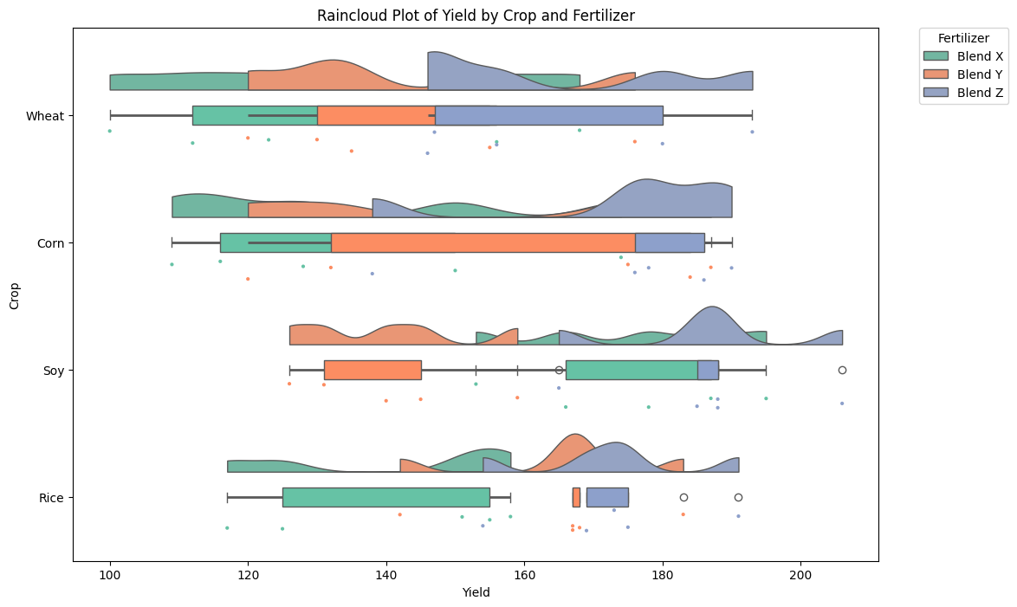
- Assumption #5: Your dependent variable should be approximately normally distributed for each combination of the groups of the two independent variables.
Remark. The dependent variable (yield) was approximately normally distributed for each combination of the groups of fertilizer and crop. This was assessed by the Shapiro-Wilk test of normality (p > .05)
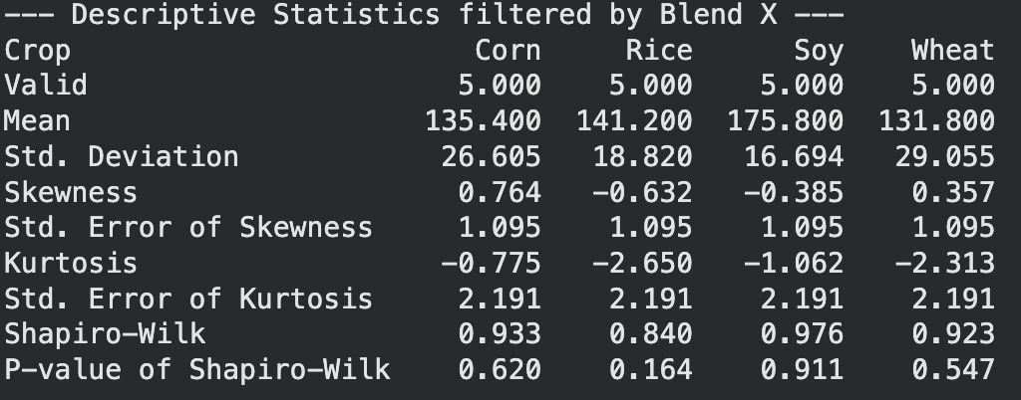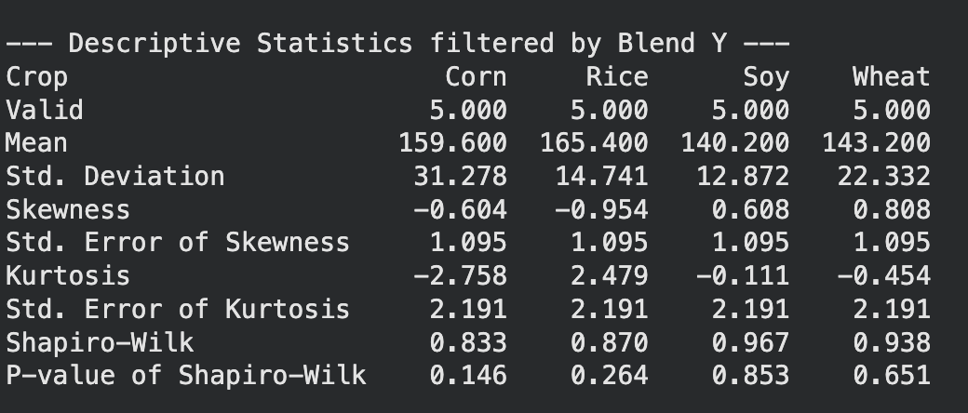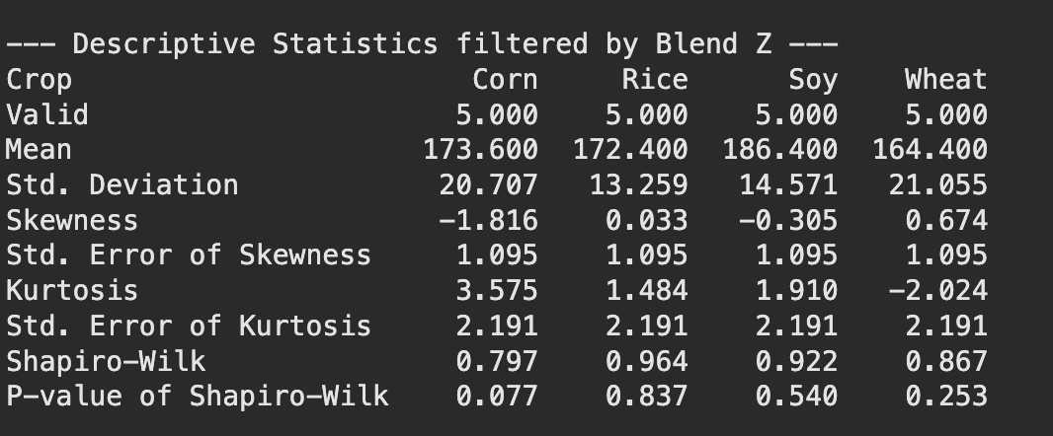
- Assumption #6: There needs to be homogeneity of variances for each combination of the groups of the two independent variables.
Remark. There was homogeneity of variances assessed by Levene’s test of homogeneity of variances (p = .755). Since the p-value is greater than .05, we can’t reject the null hypothesis, meaning the variance of the yield is equal across all combinations of fertilizer blends and crop types.

Computation:
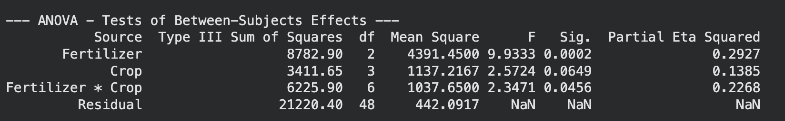
Remark. There was a statistically significant interaction between fertilizer blend and the crop type on Yield F(6, 48) = 2.3471, p = 0.0456, η²p = 0.2268. Therefore, the main effects of each independent variable shouldn’t be reported because they would be biased. So, an analysis of simple main effects for fertilizer blend and crop type will be performed with statistical significance receiving a Bonferroni adjustment and not being rejected at the p < .0125 level.
Results of Simple Main Effects
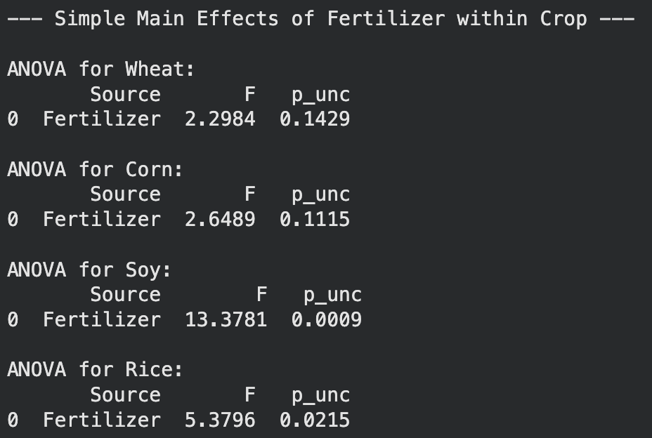
Remark. When examining the effect of fertilizer within each crop type, a significant statistic difference was only seen for Soy (F = 13.3781, p = 0.0009). No significant statistical differences between fertilizer blends were observed for Wheat (p = .1429), Corn (p = .1115), or Rice (p = .0215). These values didn’t meet the adjusted Bonferroni significance of p < .0125 (0.05/4 tests).
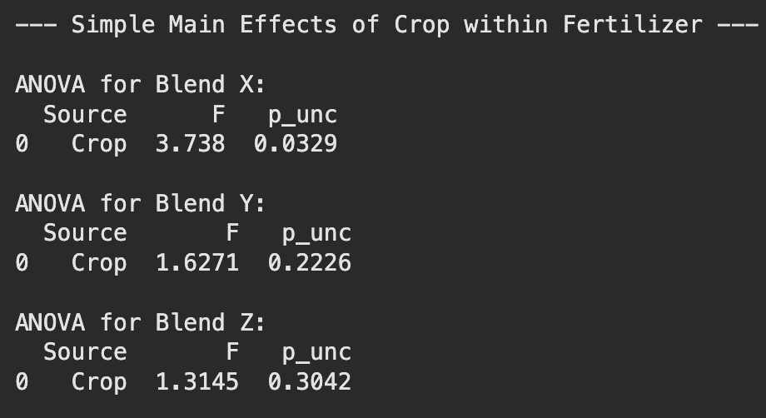
Remark. The analysis of simple main effects for crop within each fertilizer blend showed no significant statistical differences. Even though Blend X showed leaned toward differences across crops (F = 3.738, p = .0329), it still failed to reach the adjusted significance level of p < .0167 (0.05/3 tests). Also, there were no significant differences between crop types seen in Blend Y (p= .2226) or Blend Z (p = .3042).

Post-Hoc Comparisons - Fertilizer * Crop
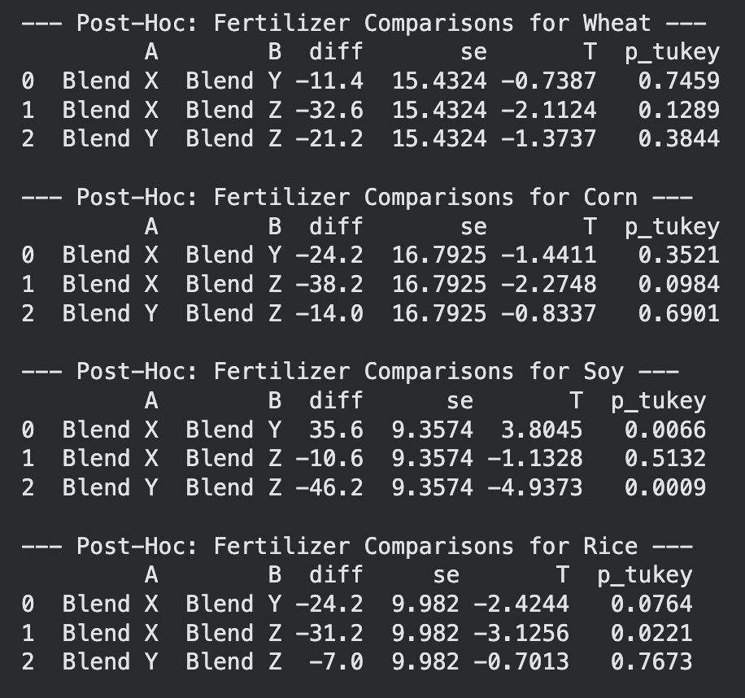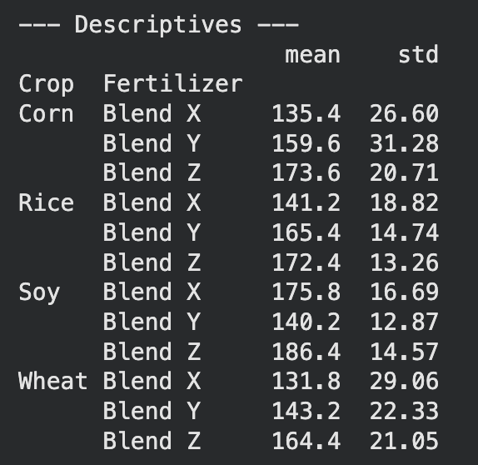
Remark. All pairwise comparisons were run for the simple main effect of Fertilizer on Wheat, Corn, and Rice with p-values Tukey-adjusted. For Wheat, there were no statistically significant differences were found between Blend X (131.8 ± 29.06), Blend Y (143.2 ± 22.33), and Blend Z (164.4 ± 21.05), all p > .05. Same for Corn, for Blend X (135.4 ± 26.60$), Blend Y (159.6 ± 31.28), and Blend Z (173.6 ± 20.71) showed no significant pairwise differences. Rice showed some higher yields for Blend Z (172.4 ±13.26) compared to Blend X (141.2 ± 18.82$), diff = 31.20, but this didn’t reach significance under the Tukey adjustment (p = .022).
For Soy, there was a significant simple main effect of Fertilizer. Soy with Blend Z (186.4 ± 14.57) had a statistically significantly higher yield than those treated with Blend Y (140.2 ± 12.87), mean difference = 46.20, p < .001. Soy treated with Blend X (175.8± 16.69) also significantly beat Blend Y, mean difference = 35.60, p = .007. However, no significant difference was found between Blend X and Blend Z (p = .513).

APA Report Summary
A two-way ANOVA (2B) was conducted to determine the effectiveness of three new fertilizer formulas (Blend X, Blend Y, and Blend Z) on the yield of four different crops (wheat, corn, soybeans, and rice). Residual analysis was performed to test for the assumptions of the two-way ANOVA. Outliers were assessed by inspection of a rain cloud plot, normality was assessed using Shapiro-Wilk's normality test for each cell of the design, and homogeneity of variances was assessed by Levene's test. There were no outliers, residuals were normally distributed (p > .05) and there was homogeneity of variances (p = .755).
There was a statistically significant interaction between fertilizer blend and crop type on Yield, F(6, 48) = 2.3471, p = .0456, η²p = .2268. So, an analysis of simple main effects for fertilizer blend was performed with statistical significance receiving a Bonferroni adjustment and being accepted at p < .0125. There was a statistically significant difference in mean yield for Soy as well, F(2, 48) = 13.38, p < .001. There is no significant differences between fertilizer blends were observed for Wheat (p = .143), Corn (p = .112), or Rice (p = .022), and these values didn’t meet the adjusted significance values.
All pairwise comparisons were run for the simple main effect of Fertilizer on Wheat, Corn, and Rice with p-values Tukey-adjusted. For Wheat, there were no statistically significant differences were found between Blend X (131.8 ± 29.06), Blend Y (143.2 ± 22.33), and Blend Z (164.4 ± 21.05), all p > .05. Corn showed for Blend X (135.4 ± 26.60$), Blend Y (159.6 ± 31.28), and Blend Z (173.6 ± 20.71) with no significant pairwise differences. Rice had some higher yields for Blend Z (172.4 ±13.26) compared to Blend X (141.2 ± 18.82$), diff = 31.20, but this didn’t reach significance under the Tukey adjustment (p = .022).
With Soy, there was a significant simple main effect of Fertilizer. Soy with Blend Z (186.4 ± 14.57) had a significant higher yield statistically than those treated with Blend Y (140.2 ± 12.87), mean difference = 46.20, p < .001. Soy treated with Blend X (175.8± 16.69) also significantly beat Blend Y, mean difference = 35.60, p = .007. However, no significant difference was found between Blend X and Blend Z (p = .513).

